1.

SOURCE:

|  |  |  |
| --- | --- | --- |
| **A** | **B** | **C** |
| 1 | 0 | NULL |
| 0 | NULL | NULL |
| NULL | NULL | NULL |

TARGET:

|  |  |  |
| --- | --- | --- |
| A | B | C |
| 1 | 2 | 3 |

Ans:

select

sum( case when A IS NULL THEN 1 else 0 end) AS A,

sum( case when B is NULL THEN 1 ELSE 0 END) AS B,

SUM( CASE WHEN C IS NULL THEN 1 ELSE 0 END) As C

from TAB_A

2. What is output after joining TAB_B and TAB_C.

TAB_B

|  |
| --- |
| A |
| 1 |
| 0 |
| NULL |

TAB_C

|  |
| --- |
| B |
| 0 |
| 0 |
| NULL |

OUTPUT:

select a.*,b.* from TAB_B a join TAB_C b ON a.A=b.B

|  |  |
| --- | --- |
| **A** | **B** |
| 0 | 0 |
| 0 | 0 |

3. Write a query to find the count of specific character in a word.

SELECT

'banana' AS word,

LENGTH('banana') - LENGTH(REPLACE('banana', 'a', '')) AS count_of_a;

4.

|  |  |
| --- | --- |
| **TAB_D** |  |
| **C1** | **C2** |
| 1 | 2 |
| 2 | 3 |
| 3 | 4 |
|  |  |
| **TAB_E** |  |
| **C1** | **C2** |
| 1 | 2 |
| 2 | 3 |
| 0 | 1 |

**Select TAB_D.*,TAB_E.* from TAB_D join TAB_E**

**on TAB_D.C1 < TAB_E.C1**

|  |  |  |  |
| --- | --- | --- | --- |
| **C1** | **C2** | **C1** | **C2** |
| **1** | **2** | **2** | **3** |

**Scenario-2**

|  |  |  |  |  |
| --- | --- | --- | --- | --- |
| **TAB_D** | |  | | |
| **C1** | | **C2** | | |
| 1 | | 2 | | |
| 2 | | 3 | | |
| 3 | | 4 | | |
|  | |  | | |
| **TAB_E** | |  | | |
| **C1** | | **C2** | | |
| 1 | | 2 | | |
| 2 | | 3 | | |
| 0 | | 1 | | |
|  | |  | | |
| **C1** | **C2** | **C1** | **C2** |
| **1** | **2** | **0** | **1** |
| **2** | **3** | **1** | **2** |
| **2** | **3** | **0** | **1** |
| **3** | **4** | **1** | **2** |
| **3** | **4** | **2** | **3** |
| **3** | **4** | **0** | **1** |

**Select TAB_D.*,TAB_E.* from TAB_D join TAB_E**

**on TAB_D.C1 > TAB_E.C1**

**scenario-3**

|  |  |
| --- | --- |
| **TAB_D** |  |
| **C1** | **C2** |
| 1 | 2 |
| 2 | 3 |
| 3 | 4 |
|  |  |
| **TAB_E** |  |
| **C1** | **C2** |
| 1 | 2 |
| 2 | 3 |
| 0 | 1 |

**Select TAB_D.*,TAB_E.* from TAB_D join TAB_E**

**on TAB_D.C1 != TAB_E.C1**

|  |  |  |  |
| --- | --- | --- | --- |
| **C1** | **C2** | **C1** | **C2** |
| **1** | **2** | **2** | **3** |
| **1** | **2** | **0** | **1** |
| **2** | **3** | **1** | **2** |
| **2** | **3** | **0** | **1** |
| **3** | **4** | **1** | **2** |
| **3** | **4** | **2** | **3** |
| **3** | **4** | **0** | **1** |

**4.**

**for each emp Show the % of total revenue before discount generated**

**by orders shipped to the USA and UK with respect to the total revenue generated by that employee**

**orders with: order_id, employee_id, ship_country**

**order_details with: order_id, unit_price, quantity, discount**

**SELECT**

**o.employee_id,**

**ROUND(**

**SUM(CASE**

**WHEN o.ship_country IN ('USA', 'UK')**

**THEN od.unit_price * od.quantity**

**ELSE 0**

**END**

**) * 100.0 /**

**SUM(od.unit_price * od.quantity),**

**2) AS percent_revenue**

**FROM**

**orders o**

**JOIN**

**order_details od ON o.order_id = od.order_id**

|  |
| --- |
| source Table |
| Name City |
| Shyam Mumbai |
| Shyam Bangalore |
| Ram Delhi |
| Ram Pune |
| Ram Chennai |
|  |
| Target Table |
| Name City |
| Shyam Mumbai,Bangalore |
| Ram Delhi,Pune,Chennai |

**6. Snowflake SCD2.**

**create or replace procedure SCD2()**

**returns string**

**language sql**

**AS**

**$$**

**BEGIN**

**MERGE INTO DIM_PRODUCT AS T USING STG_PRODUCT AS S**

**ON T.PRODUCT_ID=S.PRODUCT_ID**

**WHEN MATCHED AND (S.PRODUCT_NAME<> T.PRODUCT_NAME OR S.CATEGORY<>T.CATEGORY) THEN**

**UPDATE SET T.END_DATE=CURRENT_DATE,T.IS_CURRENT='NO'**

**WHEN NOT MATCHED THEN**

**INSERT VALUES(S.product_id,S.product_name,S.category,S.price,S.updated_date,'9999-12-31','YES');**

**INSERT INTO DIM_PRODUCT(PRODUCT_ID,PRODUCT_NAME,CATEGORY,PRICE,START_DATE,END_DATE)**

**SELECT A.PRODUCT_ID,A.PRODUCT_NAME,A.CATEGORY,A.PRICE,A.UPDATED_DATE,**

**'9999-12-31' AS END_DATE FROM STG_PRODUCT A LEFT JOIN DIM_PRODUCT B ON A.PRODUCT_ID=B.PRODUCT_ID**

**and is_current='TRUE' WHERE b.PRODUCT_ID is NULL or (A.PRODUCT_NAME != B.PRODUCT_NAME);**

**END;**

**$$**

**7.**

**Table structure- T1(C1 NUMBER) and T2(c2 NUMBER)**

**Table Values - T1(1**

**,2,**

**NULL) ---3 ROWS**

**T2(1**

**,1**

**,NULL,**

**NULL) ---4 ROWS**

**How many rows we get as output if we do Inner-2 rows , Left - 3 rows, Right-2 rows and Full Join-3 rows.**

**ANS:**

**TAB_F**

|  |
| --- |
| COL1 |
| 1 |
| 2 |
| NULL |

**TAB_G**

|  |
| --- |
| COL1 |
| 1 |
| 1 |
| NULL |
| NULL |

**INNER JOIN**

**select a.*,b.* from TAB_F a join TAB_G b on a.col1=b.col1**

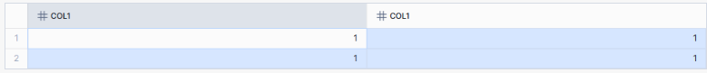

**LEFT JOIN**

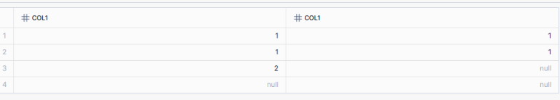

**RIGHT JOIN**

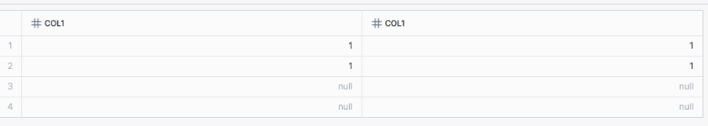

**FULL OUTER JOIN**

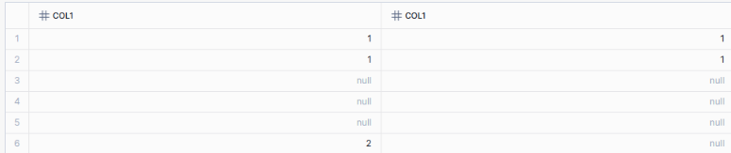

**8.**

**How to generate the Monthly report for business users using SQL query, based on below table**

**Emp(Empid number, salary number, salaryDate Date)**

**Primary Key is EmpId and SalaryDate**

**Output :-**

**MonthYear in YYYYMM format**

**Sum of Total Salary for all employees**

**Sum of Total Salary for Previous Month**

**Count of employees for each month**

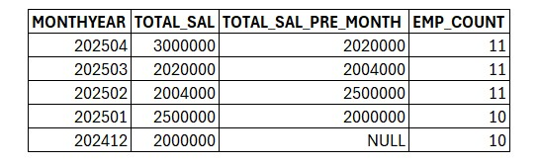

**9. Find the duplicate records emp table only based on email_id.**

**ANS:**

**select *, count(*) over(partition by email_id) as cnt from emp_1**

**10.**